Programming
Project
-  Phase 3
User Guide
Done by Brandon
Govender

TABLE OF CONTENTS

Title Sheet | Page 1
Contents Page | Page 2
Background to the project | Page 3
How to use software | Page 3
Scope and limitations of the program | Page 3
Hardware required to run program | Page 4
Software required in addition to the program itself | Page 4
Installation instructions | Page 4
List of files required | Page 5
Instructions for user and walk-through of the program | Page 6, 7, 8, 9, 10, 11, 12,13
Output/reports produced | Page 14
Troubleshooting for potential problems | Page 14
Future developments | Page 14
References and acknowledgements | Page 14

Background to the project

The P.E educator at the school finds it impractical to manually record details soccer results and the details of the teams that are participating in the tournament. It is also difficult to manually keep track of teams individual records.eg)Goals Scored in the tournament.
It is very time consuming for him to keep writing out the results after each match and also updating a teams performance ie.skill,speed,etc.
An electronic program was designed to accommodate these needs in a more timely and efficient manner.

How to use the software

The program will have a graphical user-interface, which is user-friendly so that the educator will be able to capture the details of the results from a match and as well as search for a team so that their records can be updated,etc. On loading the program the user is faced with a password menu. By entering the correct password the user would be directed to the welcome menu and thereafter the main frame. This main frame has various options, such as Inserting a new team or viewing all teams in the tournament. Depending on the users needs the appropriate option may be selected. Within the main frame there is a link to a help screen , which is easily accessible and explains to the user what is expected of them. Furthermore should the user enter invalid data appropriate error message will be displayed.

Scope

The system will enable the Teacher to perform the following:

- Insert new teams
- Delete teams
- Update team information.ie points,etc
- Search for teams by TeamName, and display the result
- Maintain an accurate positions of teams in the tournament by avoiding human error
- Display all teams in the Tournament
- Print out a log list

Limitations

The system will not be able to calculate the points after each match.(NB:This is not a system that will calculate the amount of points each team has after their match,,,it is merely in place to help the educator keep track of data,avoid human error and make the whole process less time consuming) This limitation is due to shortage of time.

Hardware required to run the program

A computer with 1Gb of RAM or more, together with a CD-ROM Drive. The computer must have atleast 20Mb of space on the hard drive. The processor speed should be atleast 2GHz. The computer should have the standard peripherals i.e mouse, keyboard and printer.

Software required in addition to the program itself

- Microsoft Windows XP installed
- Microsoft Access installed
- Microsoft Word installed
- Java IDE( NetBeans 6.0 or later ) and JDK Files
- Java run-time environment should be set up in order to run the program as an executable.If this is not so the program would have to be run from the development environment( NetBeans ).

Installation instructions

Insert the provided CD into the system CD ROM. Once the disc loads open the CD ROM drive and perform the following:

There are 2 ways to run the project from this disc.

1) Copy and paste the folder "SolvistaPremierLeague" onto a folder on your local computer. You can then run netbeans 6.0 or higher and load the project contained within this folder.

2)You can double click the executable file on this disc "SolvistaPremierLeague.exe" and follow the setup instructions which will make a copy of the project folder to the selected directory. You can then run Netbeans 6.0 or higher and load the project contained within the installed folder.

In both cases above you could run the jar file located within the installed folder
"\Spl\dist\Spl.jar". This would only work if the Java runtime environment is setup on your local computer.

List of Files required:

All files are displayed in the screen shot below which should be located in the projects “\src” folder. All these files are required for the progrma to run.
In addition the program needs the database file “LibrarySystem.mdb” which is in the project root folder.

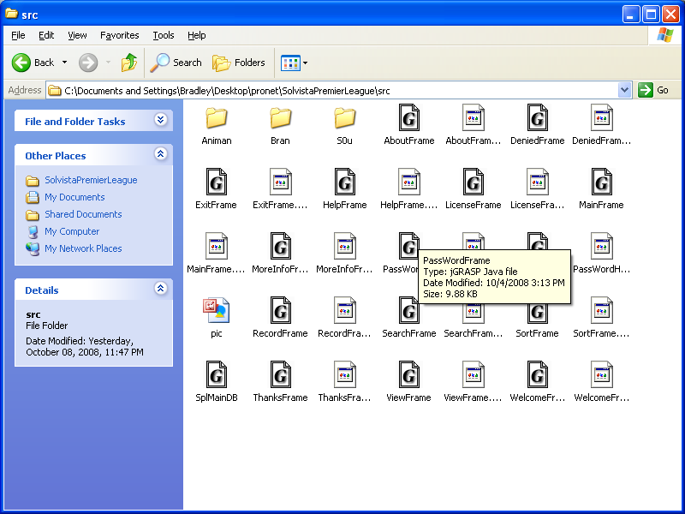

Instructions to the user and Walk-through of the program

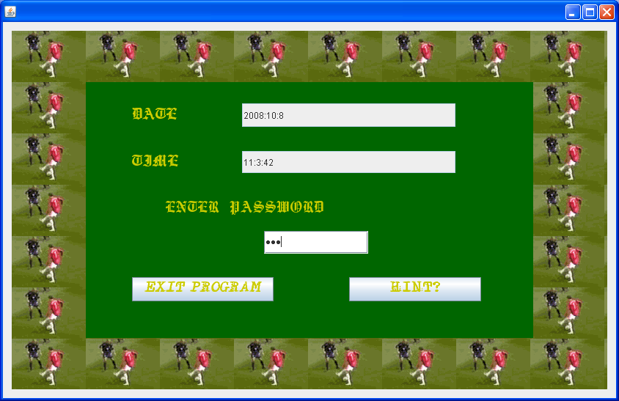

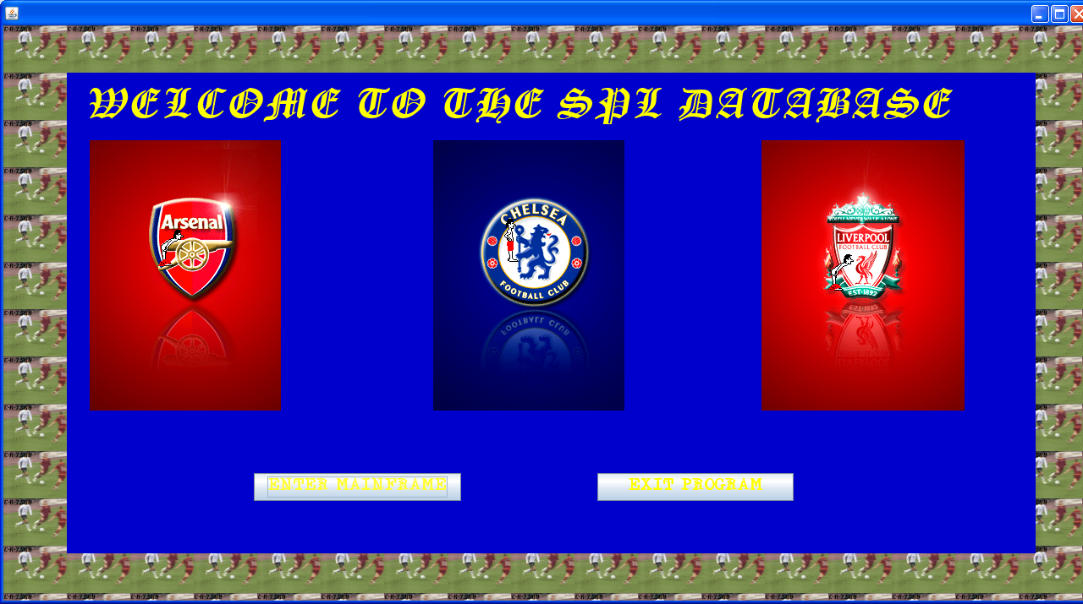

MainFrame:

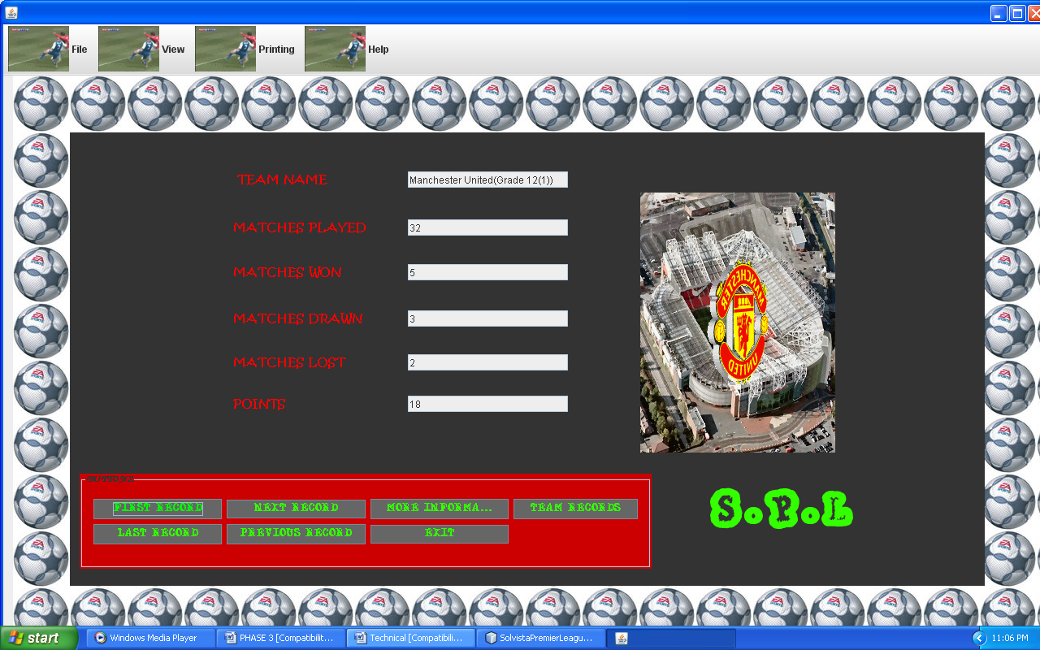

MoreInfoFrame:

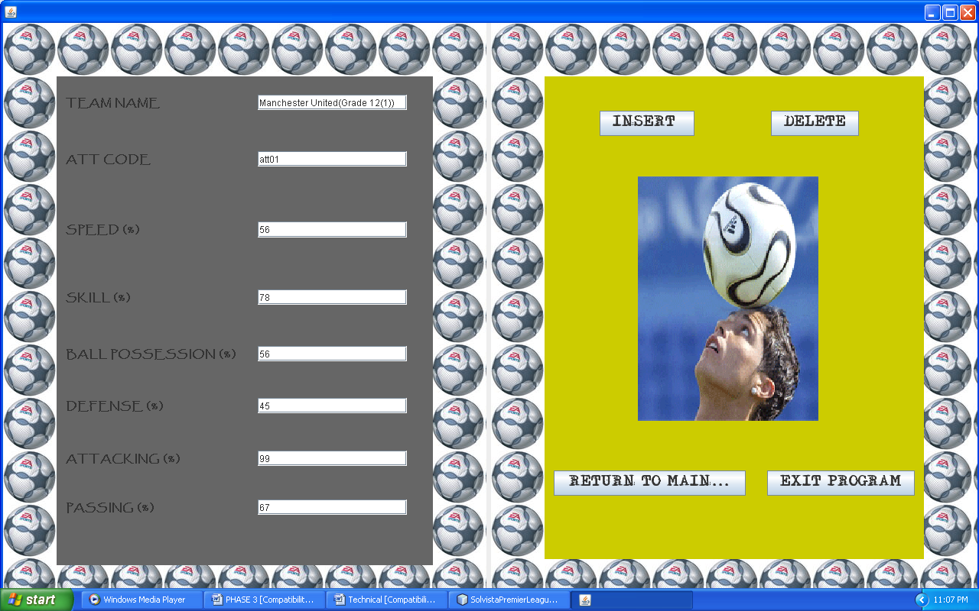

RecordFrame:
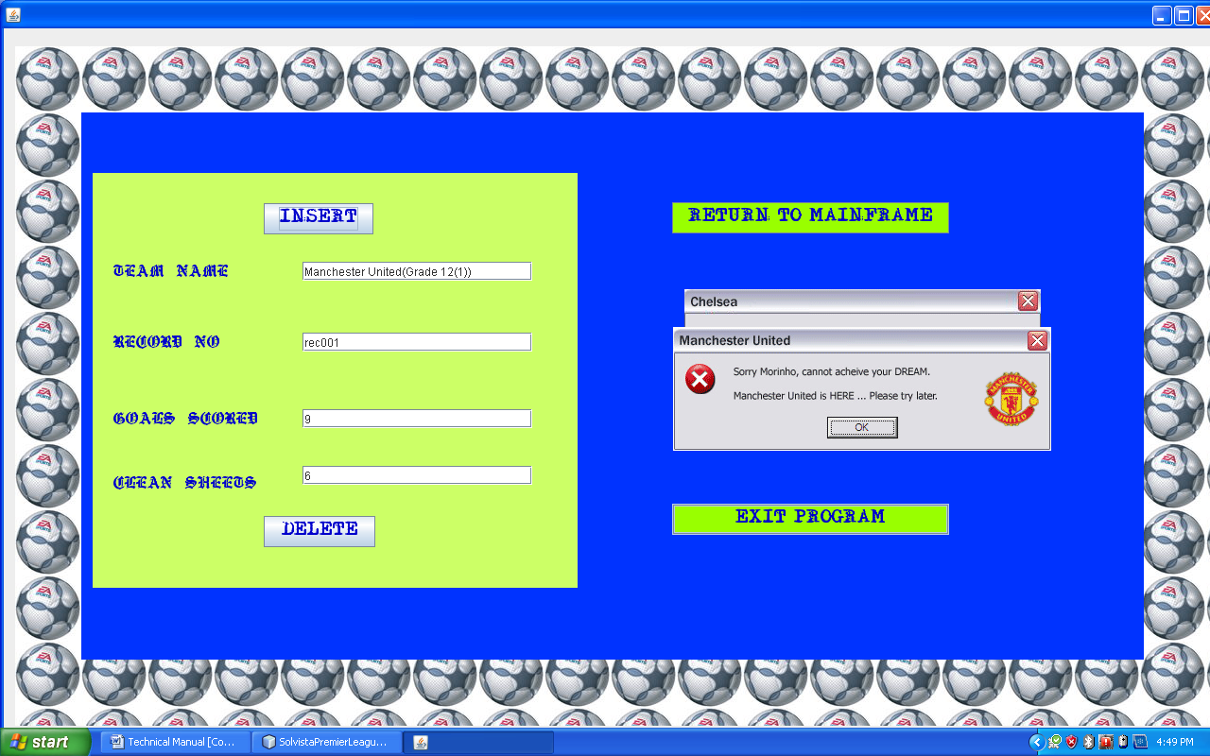

Insert:

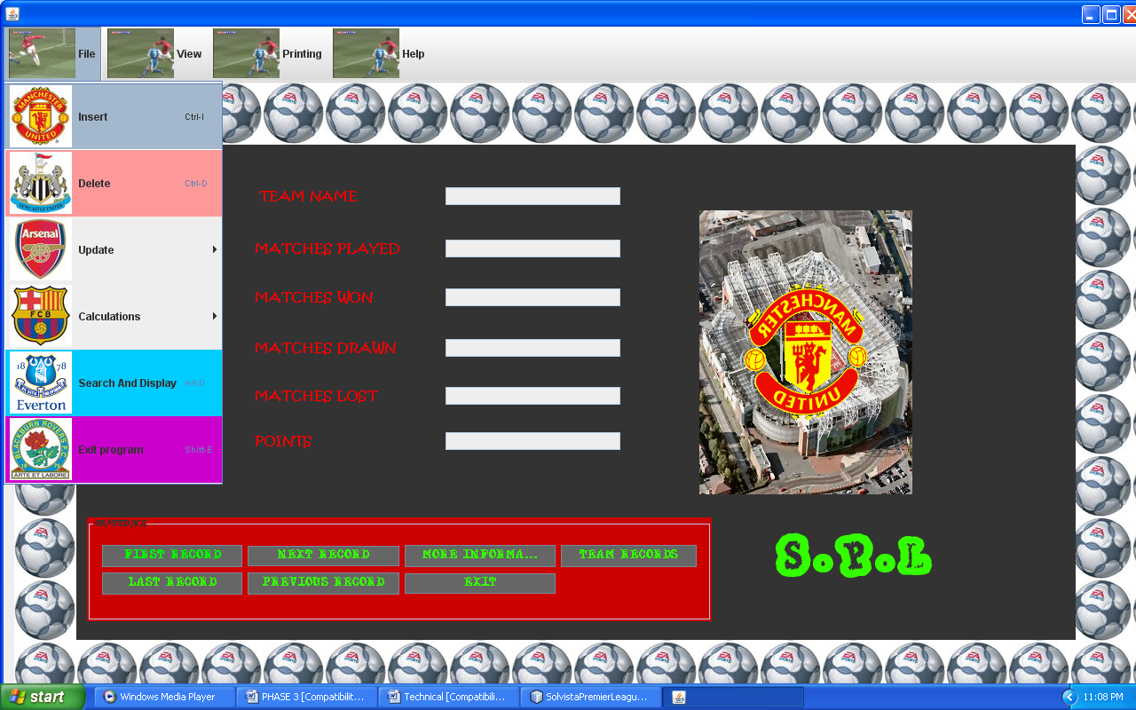

User must follow the instructions when it comes to entering data:

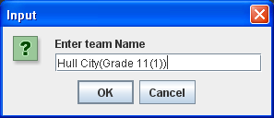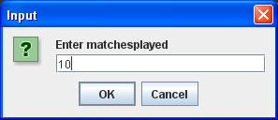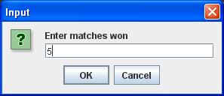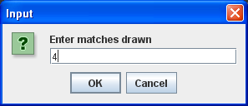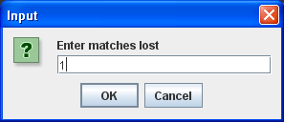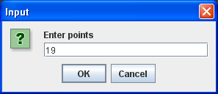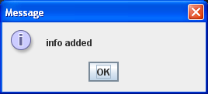
Delete:

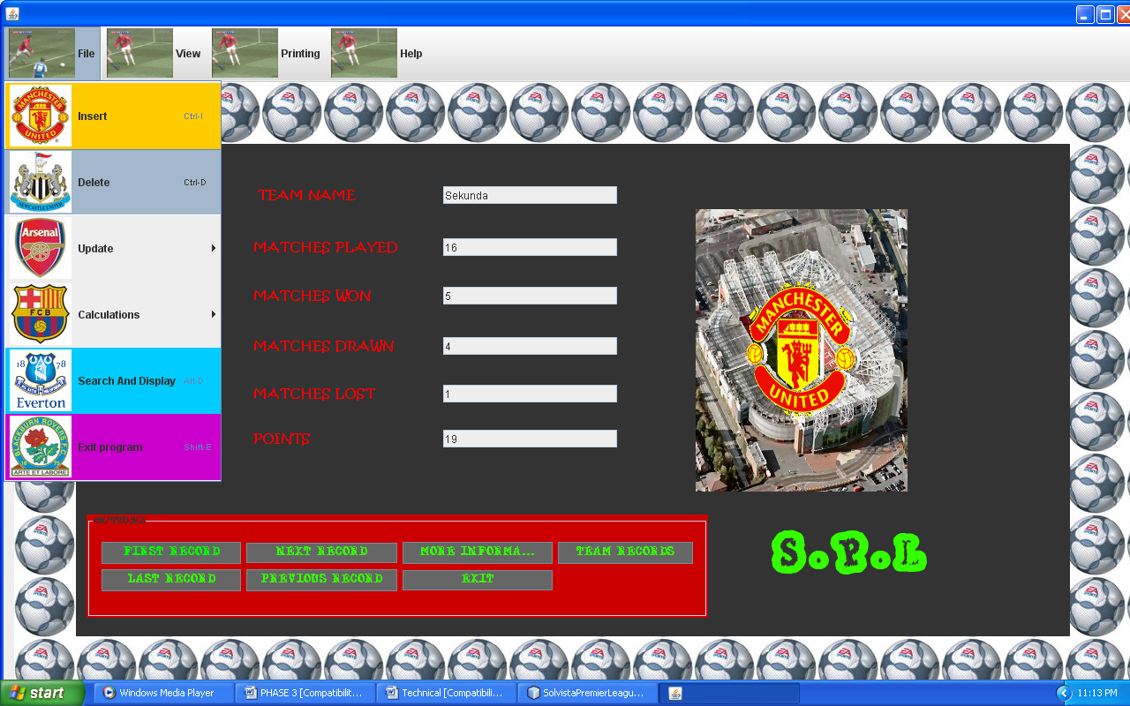

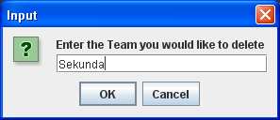

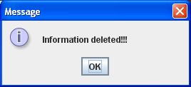

Update:
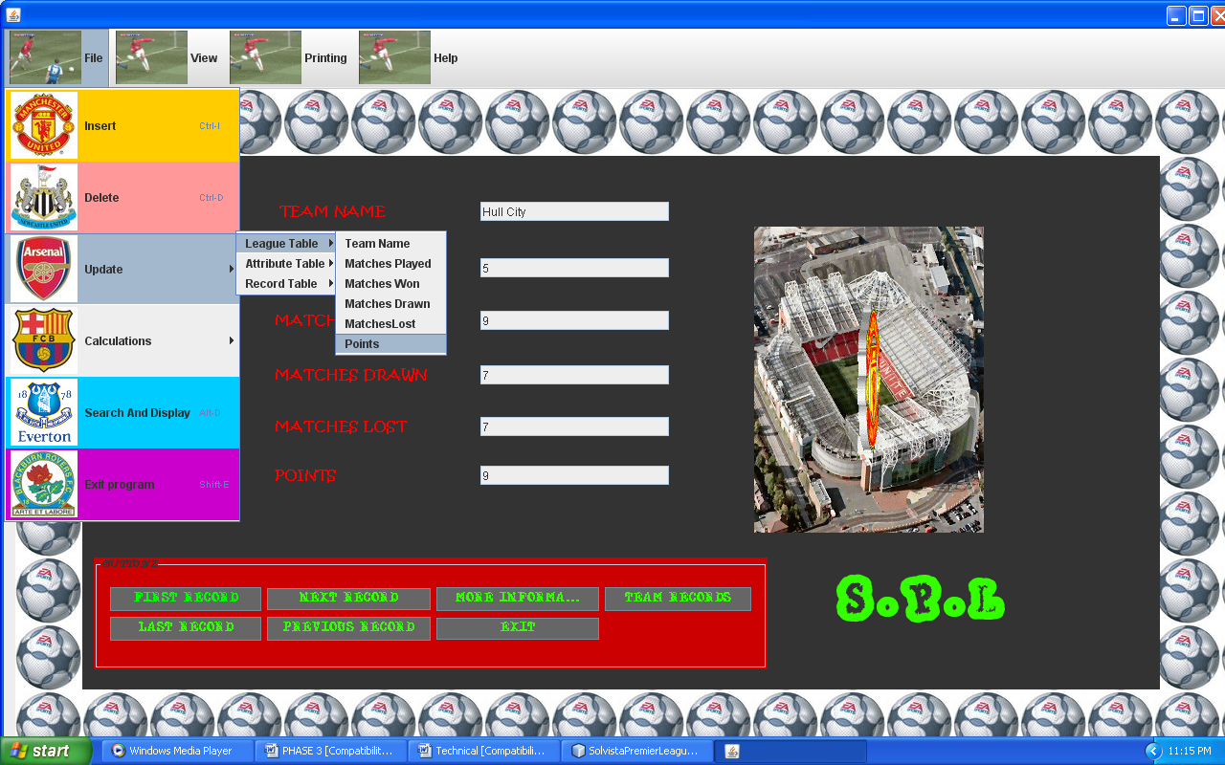

User is required to enter the ffg:
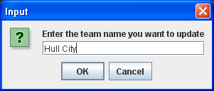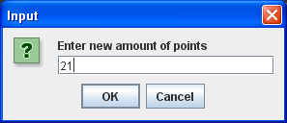
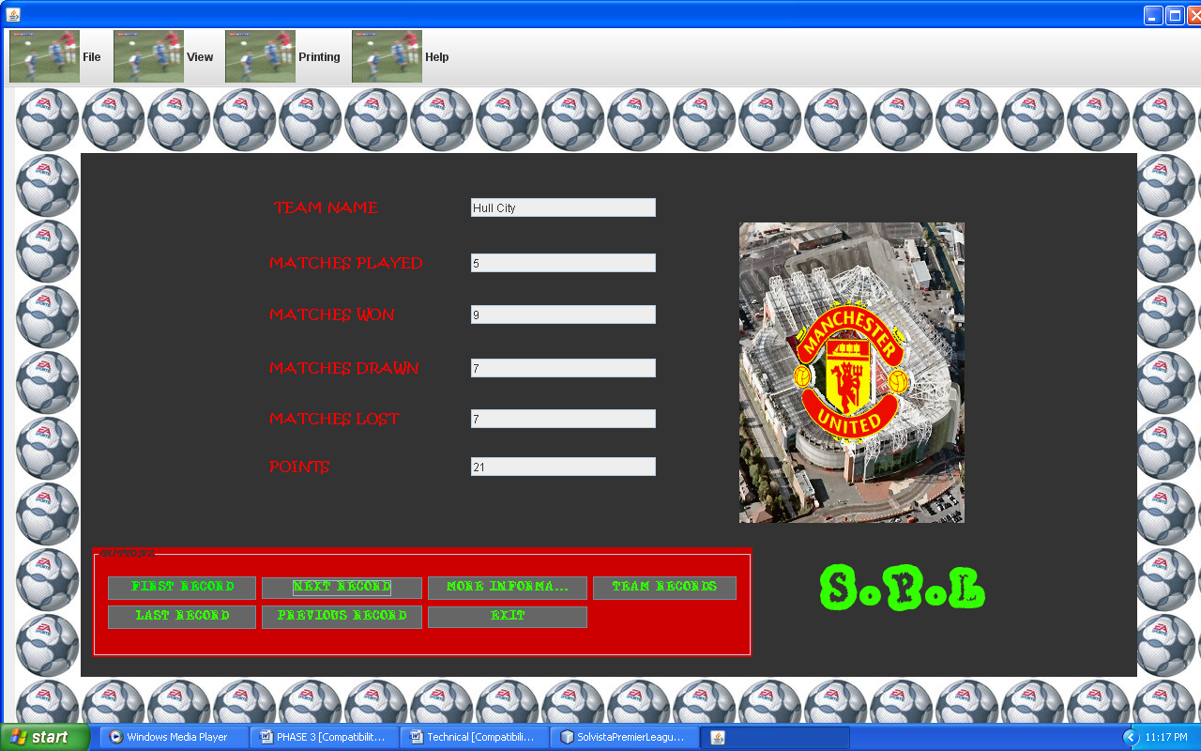

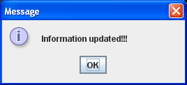

Search :

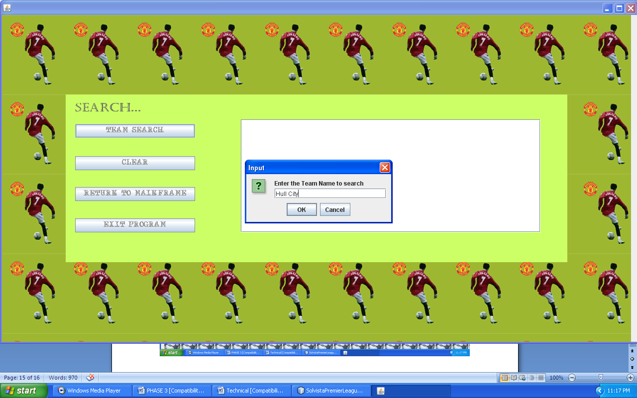
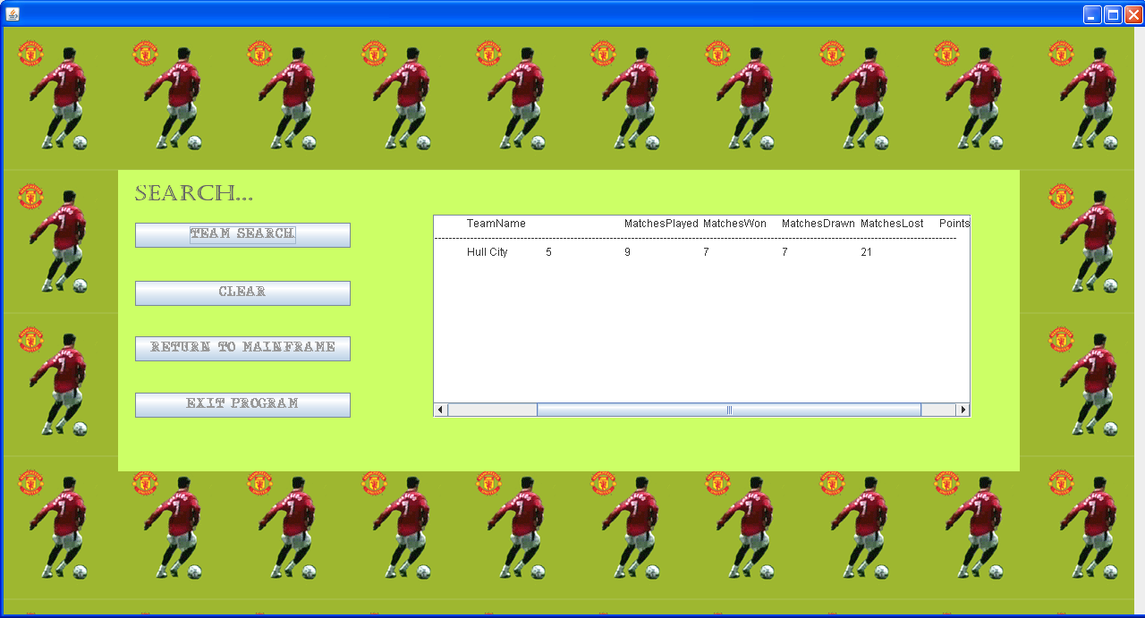

Sorting:

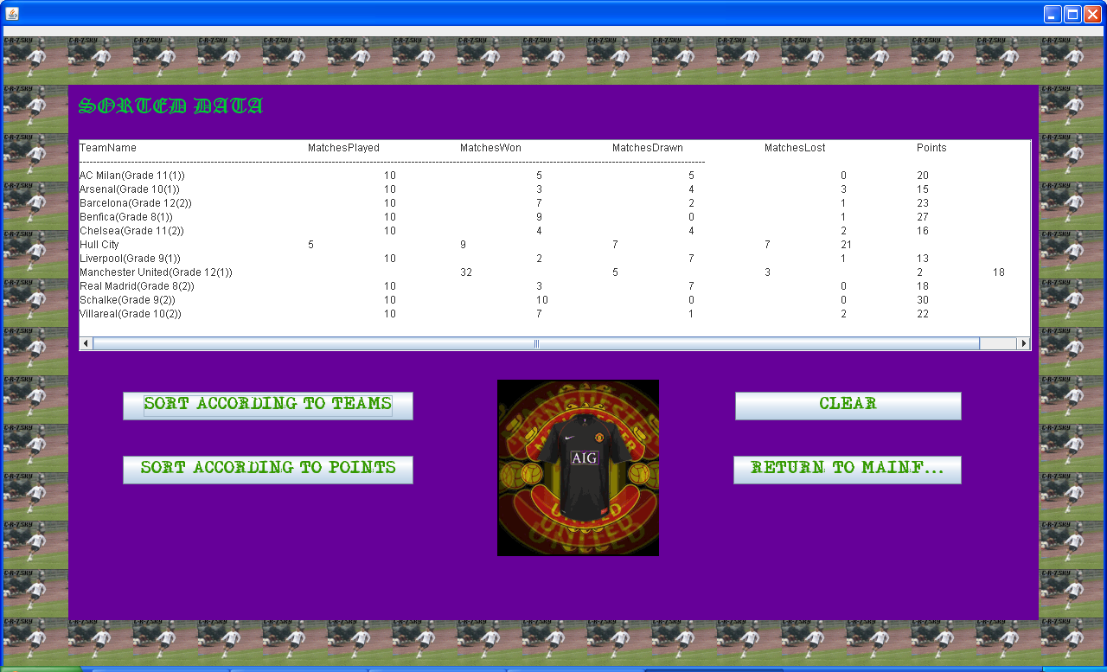

Sorted Data

Help:

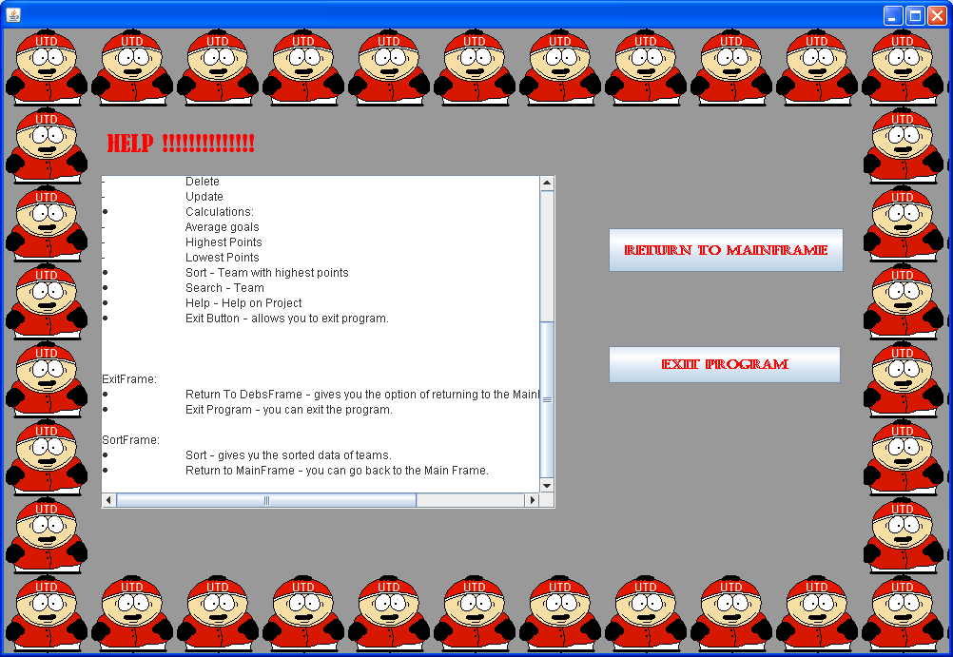

Explains to user how to use the program

Output Reports Produced
The program is able to produce reports for the user on request. Reports that can be created are:
1) A list of all teams in the system together with the details of the book.

Selecting the Display All option from the main menu and then selecting the appropriate print option on the screen can print these reports. This will show a print dialog and once ‘OK’ is selected the report will be printed to the default system printer.

Troubleshooting for potential problem

- For program that could not connect to the Database
- Ensure that the database file is in the project folder
- Appropriate message will be shown if database link was unable to be established

- For invalid Input
- Error message will be shown if field is blank or not in the desired format .For Example, entering a String when a number is required
.
- Printing Report
- Make sure there is a printer attached to the system and that the printer is online.

NB: Code is provided in the program to handle any potential problems and the program should alert the user.

Future Developments

- Calculating the points after matches have been played.
- Expanding database by having information on each player in a team.

References and acknowledgements

- Java programming made easy by G .Ramsamy.

